 | Curriculum Vitae - Ove Nilsson
2026-02-05 | Date of Birth: June 9, 1961
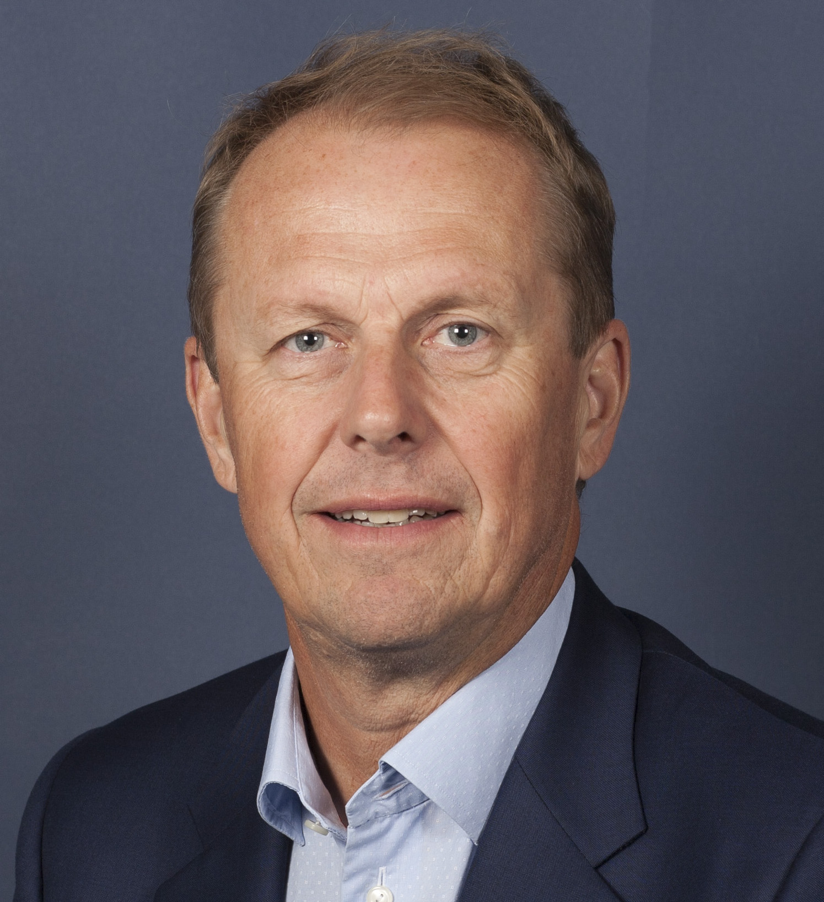 | Pippi Långstrumps Gata 28, 168 71 Bromma  070-535 50 47  ove.nilsson@mollenkloof.se

Executive Profile

Senior nuclear industry executive with 35+ years of leadership experience spanning fuel supply, regulatory oversight, operational safety, and consulting. Proven track record of integrating complex organizations, securing critical supply chains, driving cultural transformation, and scaling profitable businesses. Recognized for strategic leadership, stakeholder alignment, and delivering measurable operational and financial results in highly regulated environments.
Key Achievements

Secured long-term nuclear fuel supply for Sweden after the Russia-Ukraine crisis by rapidly sourcing alternative materials in a disrupted global market—protecting reactor operations and generating significant cost savings for the 2020s.

Led the integration of Vattenfall Nuclear Fuel AB into a new business unit, introducing a process-based governance model that improved efficiency, resilience, and employee sustainability.

Built and scaled a high-growth consulting firm, doubling revenue within five years, earning multiple national growth awards, and successfully positioning the company for acquisition by ÅF (AFRY).

Transformed regulatory operations at the Swedish Radiation Safety Authority by implementing a customer-focused culture that reduced lead times, improved transparency, and strengthened industry collaboration.
Professional Experience
Managing Director / Head of Department
Vattenfall Nuclear Fuel AB – Vattenfall | 2021–2025

Executive leader of a SEK 2–3 billion nuclear fuel business with ~70 employees.

Impact:
- Ensured reliable, cost-efficient fuel delivery to Sweden’s largest nuclear plants.
- Strengthened strategic readiness for next-generation nuclear investments.
- Represented Sweden in the Euratom Supply Agency.
- Advanced export control compliance and regulatory governance.

Head of Unit – Nuclear Operations & Decommissioning
Swedish Radiation Safety Authority | 2016–2021

Led national oversight of nuclear facilities handling radioactive materials and waste.

Impact:
- Enhanced regulatory clarity and predictability for license holders.
- Improved planning horizons and operational dialogue across the sector.
- Bureau Member, OECD/NEA Committee on Decommissioning.

CEO
ES-konsult | 2001–2011

Transformed a technical consultancy into a recognized industry leader.

Impact:
- Increased revenue to ~SEK 65M and doubled headcount to 50+.
- Maintained strong margins (5–8.5%) while scaling operations.
- Achieved ISO 9001 certification and implemented continuous improvement systems.
- Expanded geographically and strengthened employer brand to attract top talent.
- Successfully prepared the company for acquisition (completed in 2014).

Consultant & Business Developer
Etteplan Sweden AB / Mollenkloof AB | 2011–2016

Led major safety modernization programs within Swedish nuclear power.

Impact:
- Directed critical projects in the Forsmark Safety Enhancement Program.
- Provided independent evaluations of large-scale organizational transformations.
- Supported requirement governance, quality assurance, and technical coordination.
Earlier Career
Held progressive technical and leadership roles including Safety Engineer, Simulator Instructor, and Control Room Operator. Built deep operational expertise in reactor safety, emergency preparedness, and training across international environments.
Education
- Diploma in Operations and Maintenance Engineering, Mälardalen University
- Upper Secondary Engineering Diploma, Teknikum Växjö
- Executive Coaching: CEO leadership development (2008–2012)
Leadership Strengths

Strategic Leadership • Business Transformation • Organizational Development • P&L Accountability

Nuclear Operations • Regulatory Affairs • Supply Chain Security
Stakeholder Management • Safety-Critical Environments • International Collaboration
Personal
Based in Stockholm with family. Active in professional networks and leadership forums. Interests include golf, travel, and fitness.

